**User Manual**



Course Registration System (CRS)

Version: Beta 1.1

2013

**CRS User Manual**

**Contents**

**1. Log in…………….………………………………………………………….Page 3**

**2. Administrator Functions**

**2.1 Administrator Interface……………………………………………...Page 5**

**2.2** **Administrator Course Interface……………………………………..Page 6**

**2.3** **Administrator Student Interface…………………………………….Page12**

**3.** **Student Functions**

**3.1** **Student Interface………………………………………………...……Page18**

**3.2** **Register/Drop Course Interface……………………………………...Page19**

**3.3** **Show All Courses Interface…………………………………………..Page23**

**3.4** **Modify Information Interface………………………………………..Page24**

**3.5** **Show All Grades……………………………………………………....Page26**

**3.6 Change Password……………………………………………………..Page27**

**4. Exit…………………………………………………………………………...Page30**

**5. Developers…………………………………………………………………...Page31**

**1. Log in**

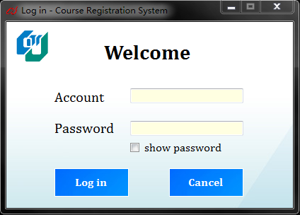

Interface

 Account input  Password input

 Show password  Log in button

 Cancel button

**Cases:**

1. Hide the password for safety

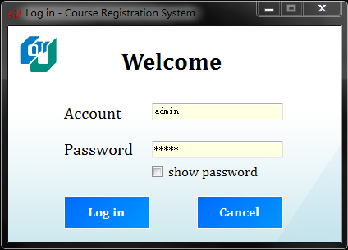 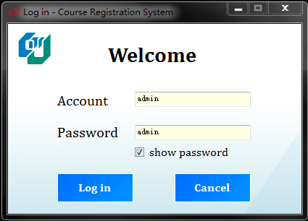

2. Wrong password OR Wrong account

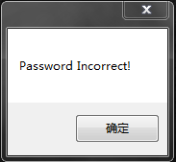 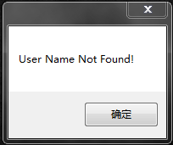

3. Connecting successfully

 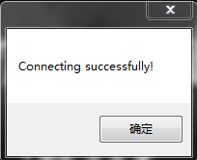

**2. Administrator Functions**

**2.1-Administrator Interface**

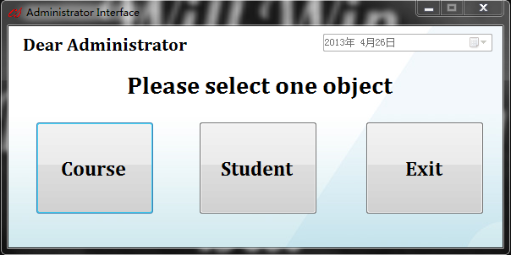



Interface

 Call course interface  Call student interface

 Exit

**2.2-Administrator Course Interface**

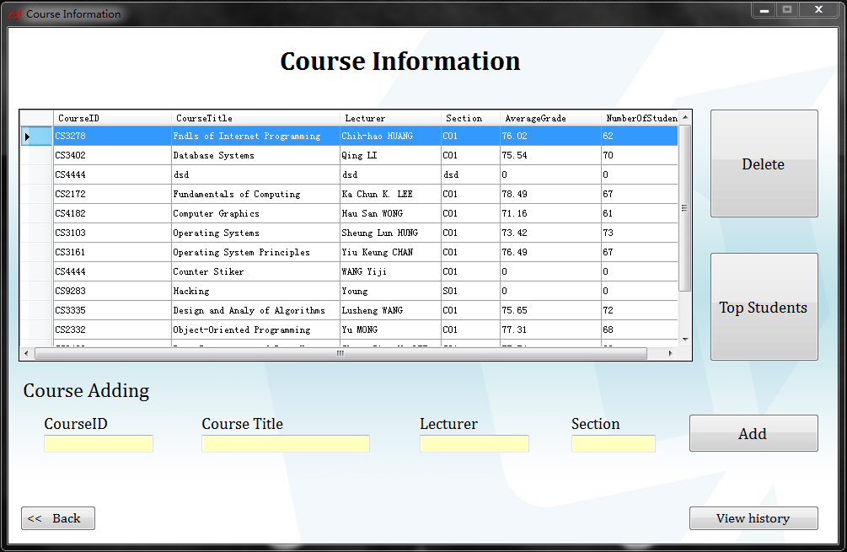

Interface

 List all the courses

 Information for the course to be added

 Delete a selected course

 List top students in the selected course

 Add a course

 View the history containing the courses deleted before

 Back to administrator interface

**Cases:**

1. Course information not completed

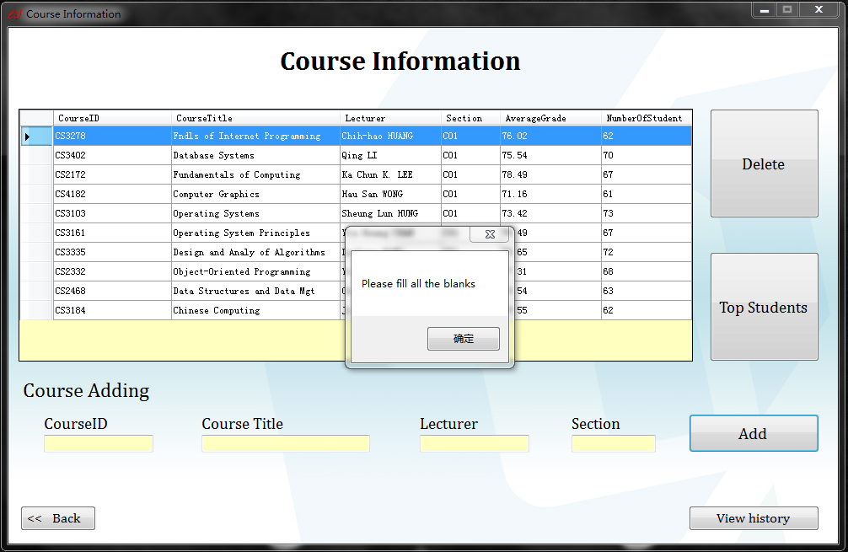

2. Add two courses with same course ID

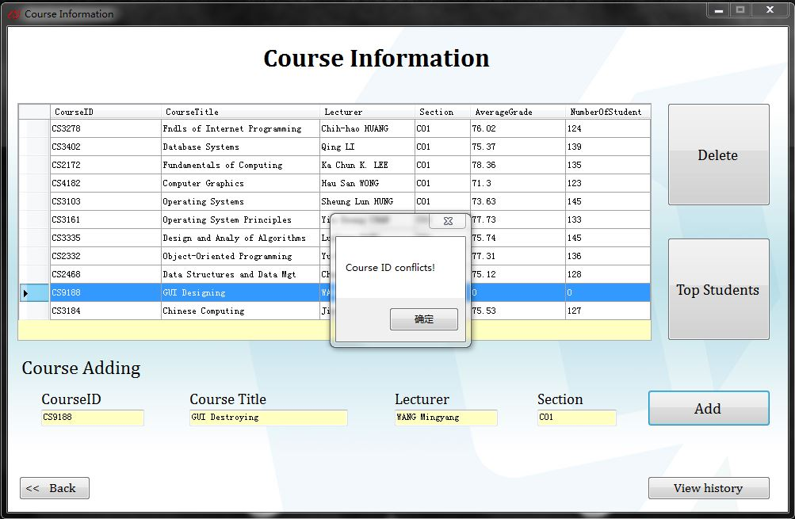

3. List top students in the selected course

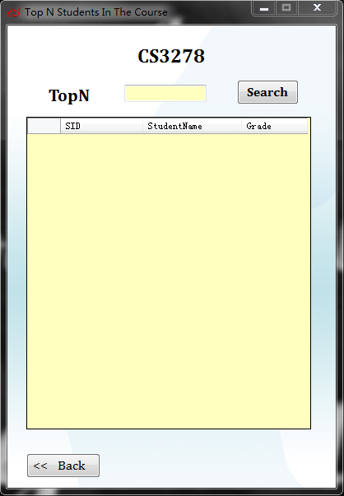

Interface

 Selected course ID  Number of top students wanted

 Search the students  Show the students

 Back

Cases:

(1). List the wanted number of top student in the selected course

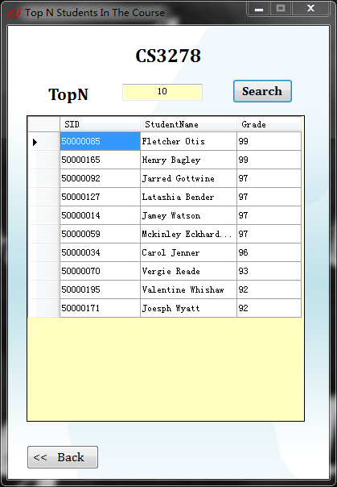

(2). Invalid input will not be accepted (not figure OR out of range)

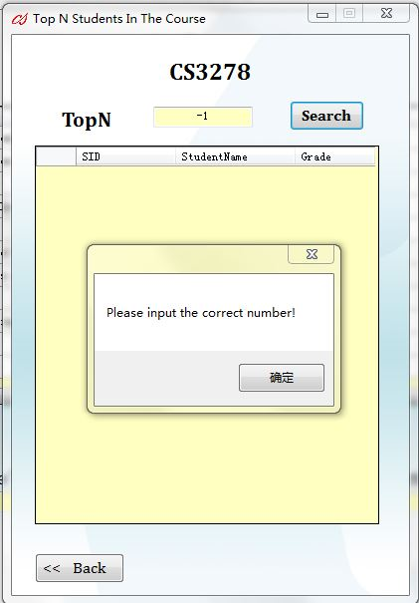

4. View the delete history and recover

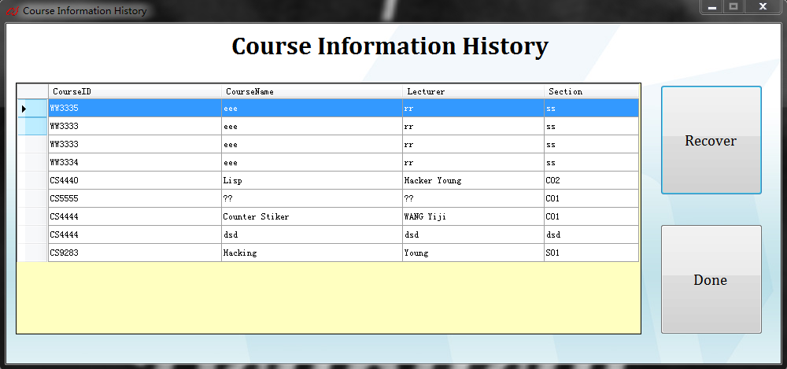

Interface

 List all deleted course

 Recover the selected course

 Back

**Cases:**

(1) Recover successfully

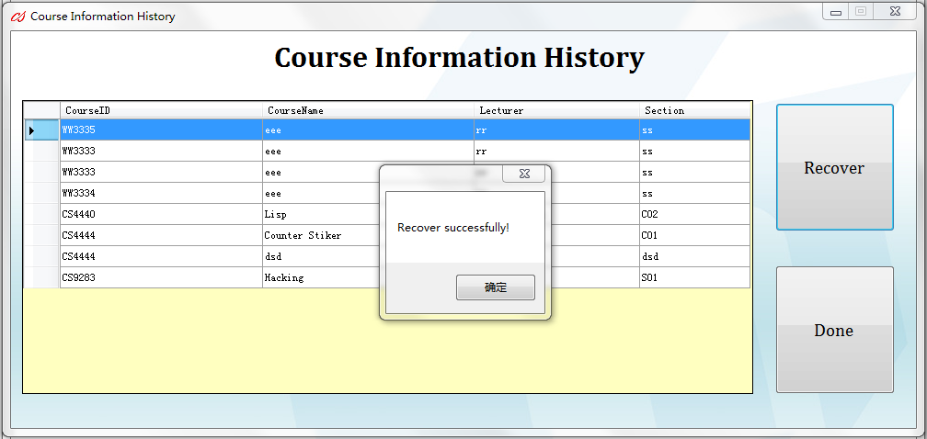

**2.3-Administrator Student Interface**

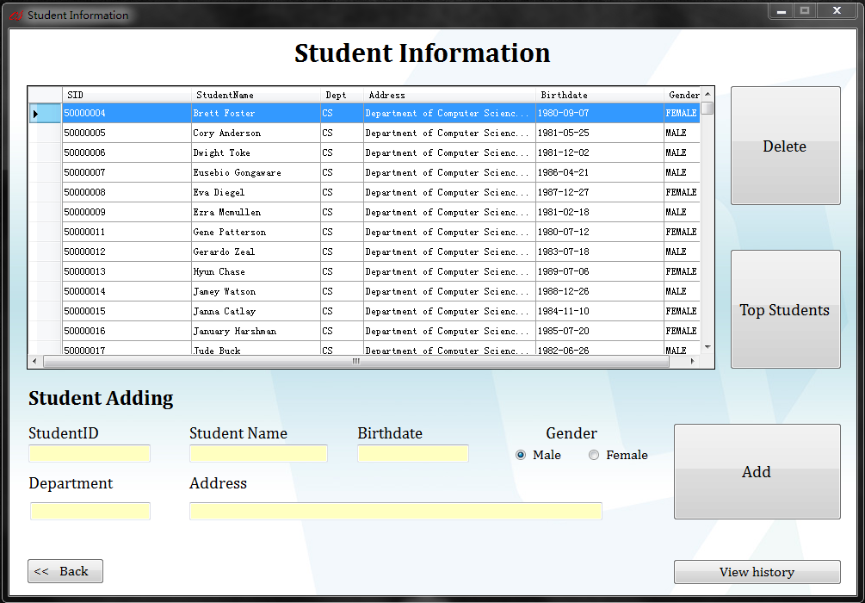

Interface

 List all the students

 Information of the student to be added

 Delete a selected student

 List top students in the whole university

 Add a student

 View the history containing the students deleted before

 Back to administrator interface

**Cases:**

1. Student information not completed

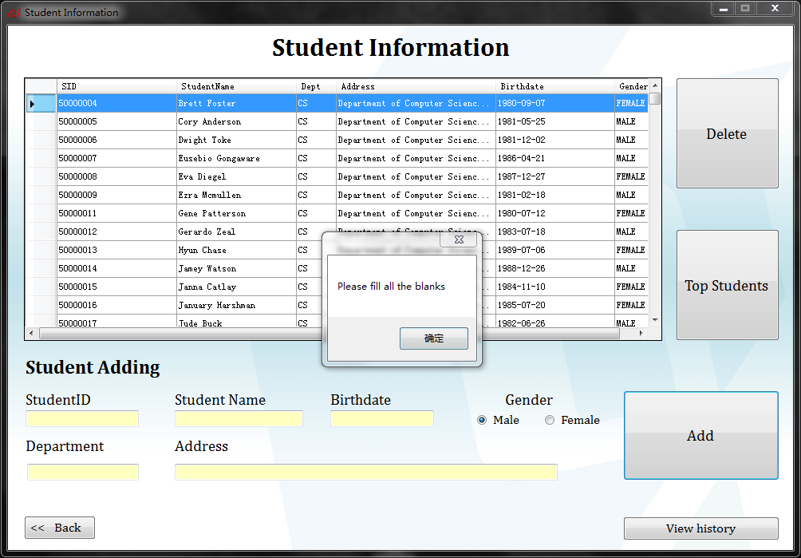

2. Add two students with same student ID

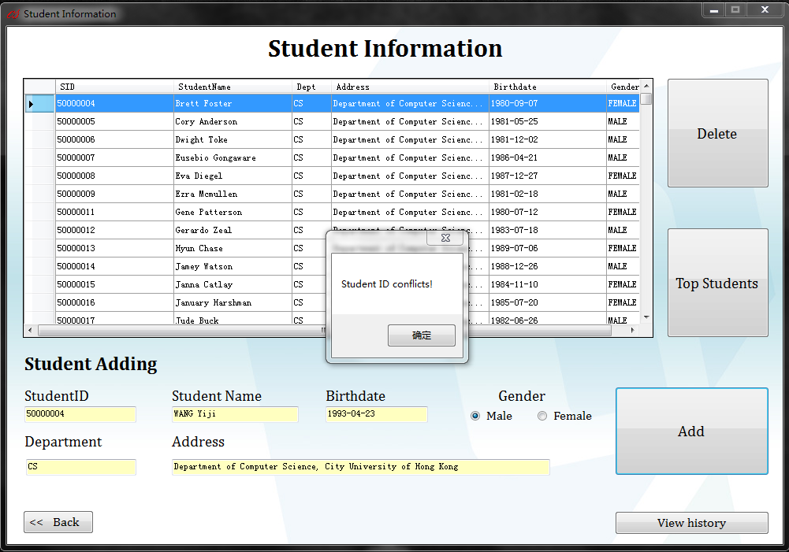

3. List top students in the whole university

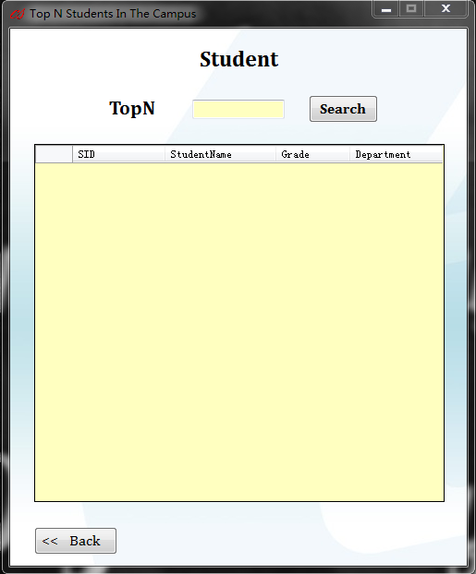

Interface

 Number of top students wanted  Search the students  Show the students  Back

**Cases:**

(1). List the wanted number of top student in the university

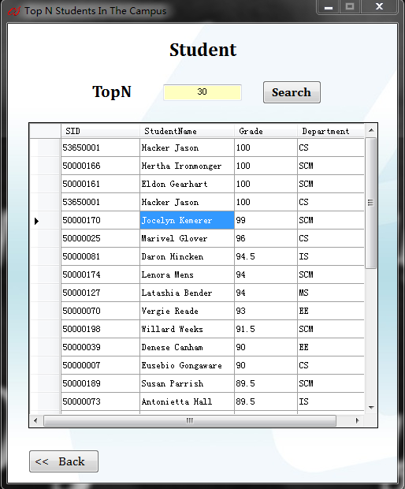

(2). Invalid input will not be accepted (not figure OR out of range)

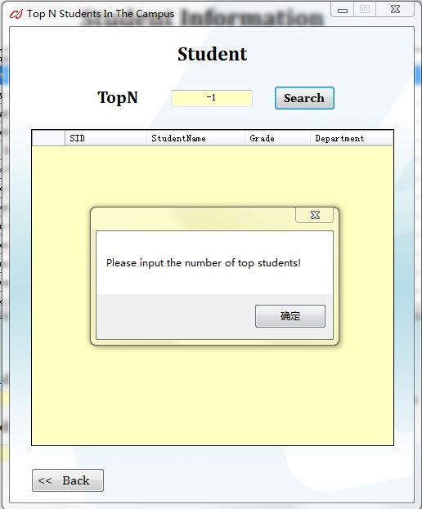

4. View the delete history and recover

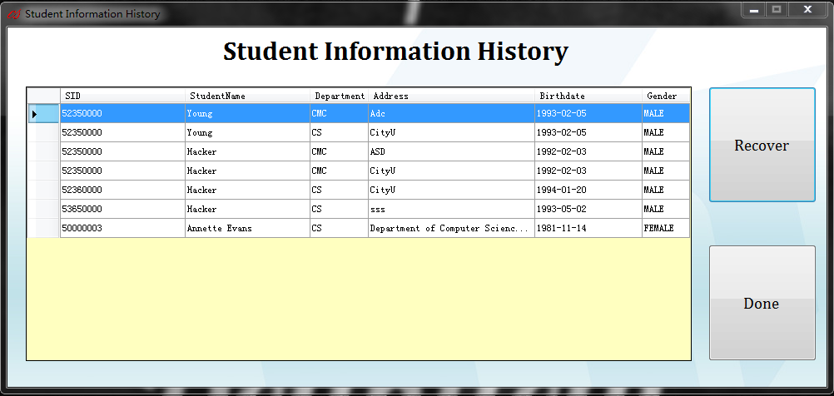

Interface

 List all deleted students

 Recover the selected student

 Back

**Cases:**

(1) Recover successfully

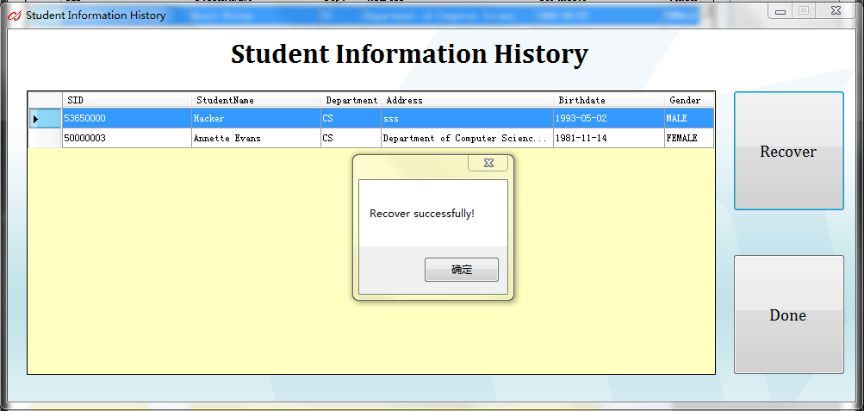

**3. Student Functions**

**3.1-Student Interface**

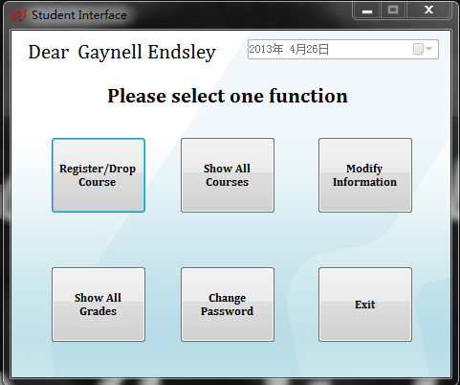

Interface

 Name of the student user  Current date

 Register/Drop course  Show all courses

 Modify personal information  Show grades of courses

 Change user password  Exit

**3.2-Register/Drop Course Interface**

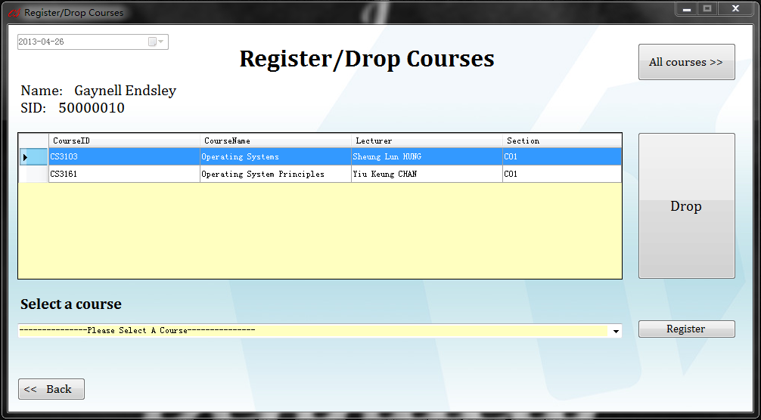

Interface

 Current date  Basic information of user

 Course taken by user  All courses to be chosen

 Show all courses  Drop a selected course

 Register a selected course  Back to the interface

**Cases:**

1. Register course conflict

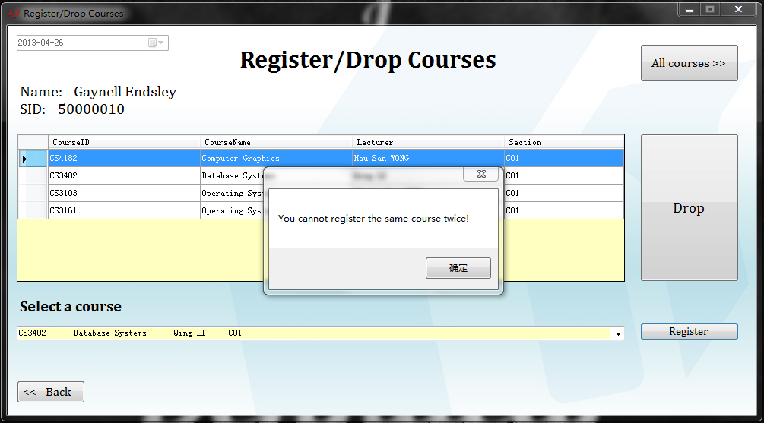

2. Register not allowed more than 6 courses

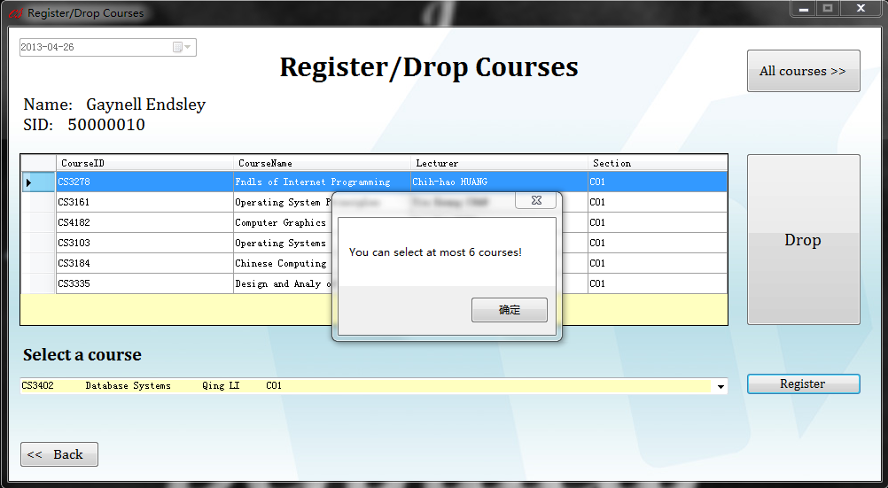

3. Warning before input grade

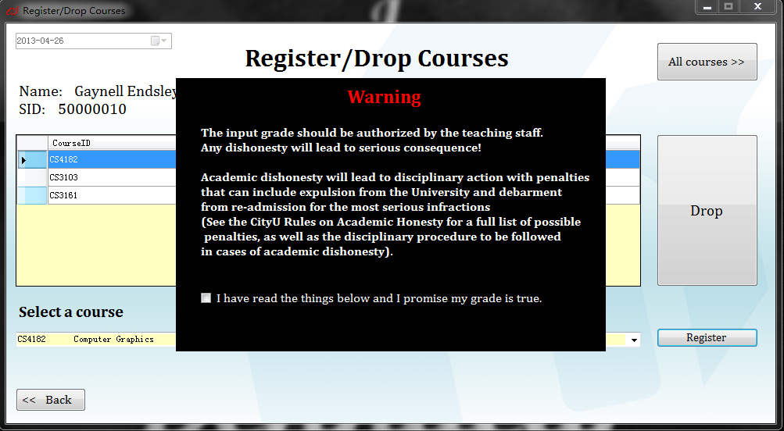

(continue only if user agrees with the provision)

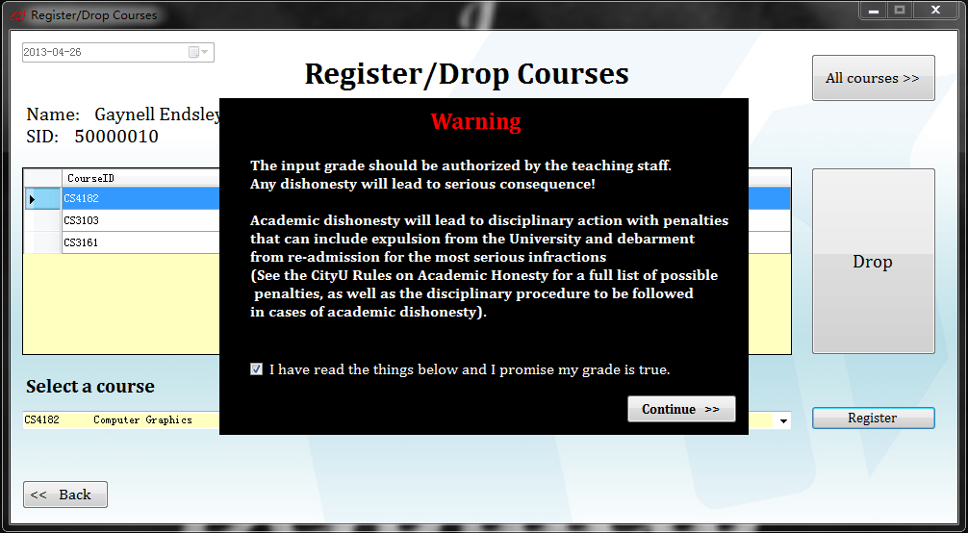

4. Input grade successfully

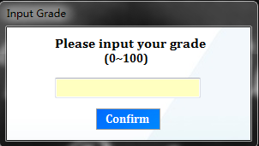 

5. Input error

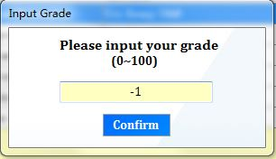 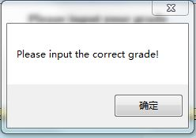

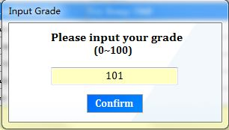 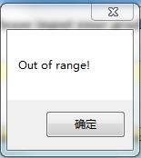

6. Show all courses (0 for no one taking the course)

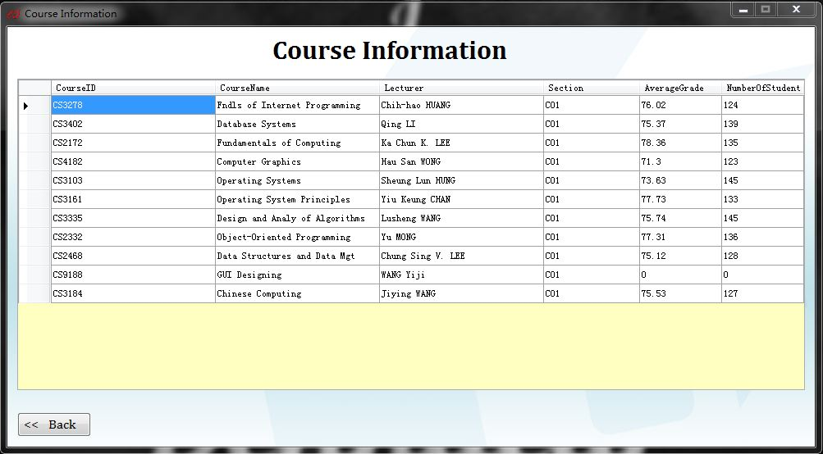

**3.3-Show All Courses Interface**



Interface

 Show average grades and number of students of the course

(0 for no one taking the course)

 Back

**3.4-Modify Information Interface**

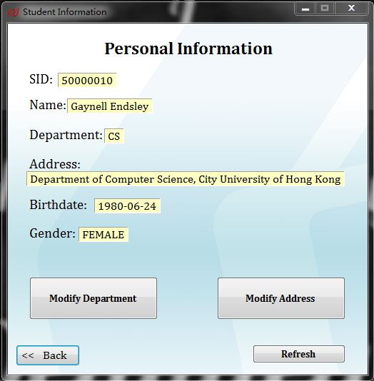

Interface

 Basic information of the user

 Call modify department interface

 Call modify address interface

 User should refresh to see the update

 Back

**Cases:**

1. Modify address successfully

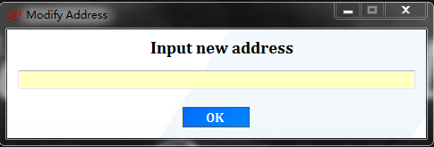 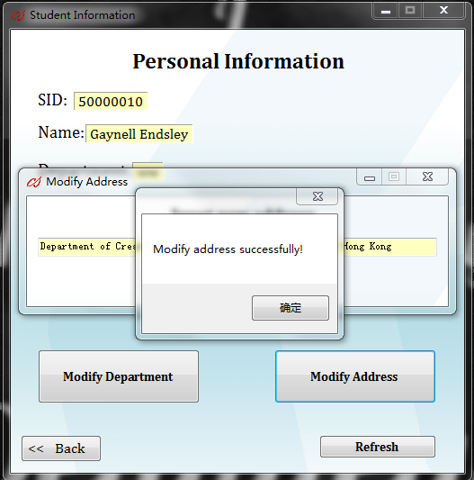

2. Modify department successfully

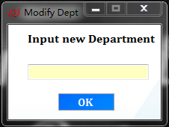 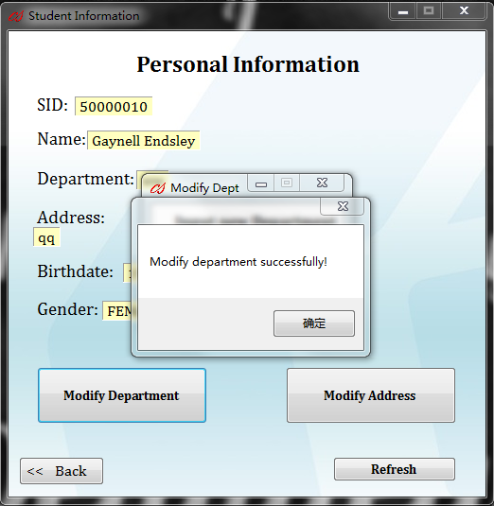

**3.5-Show All Grades**

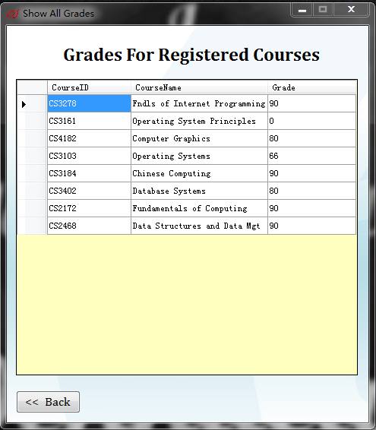

Interface

List all registered courses and grades  Back

**3.6-Change Password**

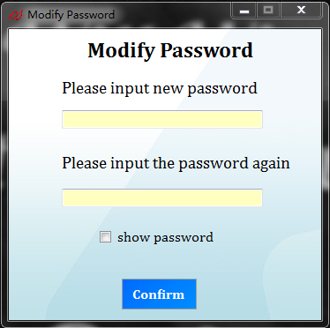

Interface

 Input new password and confirm it

 Show password

 Confirm button

**Cases:**

1. Hide the password for safety

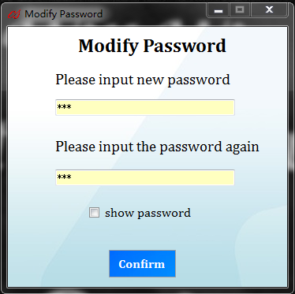 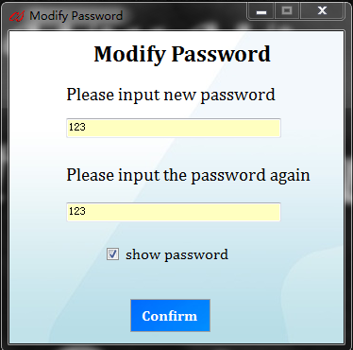

2. Password not correctly confirmed

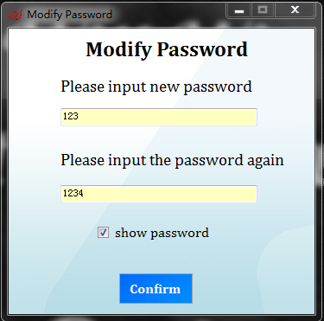 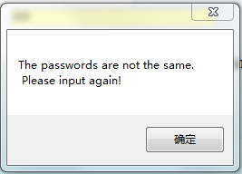

3. Modify password successfully

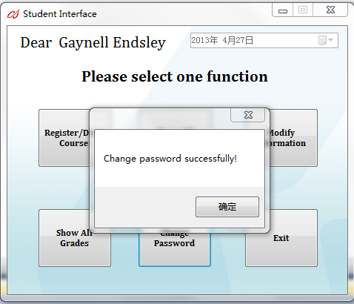

**4. Exit**



Appear for 5 seconds after clicking “Exit” button

**5. Developers**

1. WANG Mingyang (Young)

2. WANG Yiji (Jason)

For any bugs or questions, please feel free sending e-mail to the following address:

[CS.Jason.Wong@my.cityu.edu.hk](mailto:CS.Jason.Wong@my.cityu.edu.hk)

[mingywang3@my.cityu.edu.hk](mailto:mingywang3@hotmail.com)

END